Call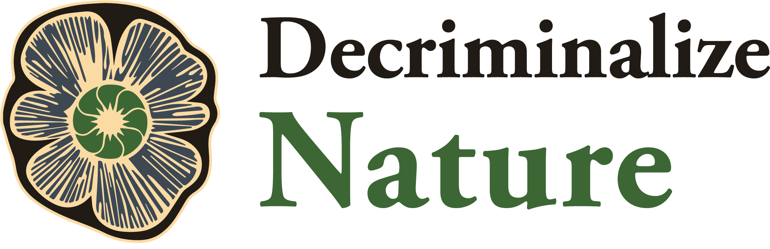

**Decriminalize Nature’s Policy on Non-Commodification**

* Whereas, we are in the midst of an environmental crisis resulting, in large part, from human-created causes, and
* Whereas, the human connection to nature has been increasingly eroding since the onset of the industrial revolution in the 18th Century, and
* Whereas, the need for humans to deepen their connection to our natural world is more important than ever, and
* Whereas, For-Profit Publicly Traded and Closely Held Corporations (C, S, and B) and Limited Liability Corporations (LLCs), while important tools for commerce and economic growth, have not been able to successfully incorporate humane, spiritual, and environmentally sensitive values into their bottom lines, and
* Whereas, corporate influence in our political system is at an all-time high when coupled with the national trends toward lax lobbying rules, gerrymandering, and voter suppression efforts, and
* Whereas, a recent study by Forbes Magazine found that African American and Latinos were far less likely to qualify for business loans relative to their white counterparts in the cannabis industry, and
* Whereas, white businesses represent 81% of all business in cannabis, despite the US white population being 60%, and
* Whereas, a recent study by the Drug Policy Alliance identified that African American and Latinos represent 80% of the incarcerated population in America for drugs, while representing only 10% of businesses in the Cannabis industry (Source), and while representing 40% of the American population, collectively, and
* Whereas the corporatization of cannabis has been shown to reduce equitable access for marginalized communities to permits, products, and business opportunities,
* Whereas business articles about psychedelics are already touting it as the next billion dollar industry
* Whereas inherent to for-profit corporations is the desire to maximize returns at the cost of other motives, often encouraging the scarcity of product as a means of increasing profitability,
* Whereas, Decriminalize Nature holds that the relationship of humans toward entheogenic plants should be one of reverence and that the process of healing from sacred plants and fungi is most effective when they are approached as a sacred experience,

Now Therefore,

* DN recognizes that economic value is created from the any or a combination of the following: natural materials, labor, or intellectual property, and of these the entheogenic plants and fungi material should not be commodified as they are a public good created by nature in collaboration with our ancestors.
* DN is calling for a ten-year minimum moratorium on commodification of entheogenic plants and fungi by any for profit corporate entity (S-Corp, C-Corp, B-Corp, LLC) seeking to gain profit from the direct sales of sacred plants and fungi
* DN believes all policy must begin with decriminalization to allow equitable access to the general public, and decriminalization should never be repealed by following regulatory frameworks. Criminalization through regulation perpetuates the drug war for disenfranchised communities who cannot afford treatment. The medical and clinical framework should not use law enforcement and criminalization to require people to follow their regulations.
* DN believes all decriminalization measures must not prohibit personal growing, use, and trade outside of regulatory frameworks.
* DN believes entheogens refer to natural ethnobotanicals, which are often erroneously labeled as “drugs” while in fact distinct and unrelated to “drugs”.
* DN believes the Controlled Substances Act creates a false dichotomy, requiring “medical value” to be rescheduled. Inherent to the process are clinical trials, which often require production of a pharmaceutical grade synthetic ready to go to market. The Controlled Substances Act should not control entheogenic ethnobotanicals, which cannot be rescheduled because there is little funding and few trials for whole plant medical research. Natural plants and fungi should not be scheduled.
* DN believes professional activities involving entheogens should operate through models like collectives, nonprofits, churches, sole proprietorships, accredited educational institutions, or open source research.
* DN supports and encourages knowledge exchange programs between traditional indigenous wisdom keepers and contemporary cultures on entheogenic practices.
* DN recommends researching local flora and fauna to discover how to ethically source local and sustainable plants. We support bringing awareness to endangered entheogenic plants as well as co-creating new growing environments to proactively protect plants whose native land is endangered by mining and agricultural business.
* DN encourages any groups or individuals engaged in wild-harvesting a particular plant to have a robust replanting practice to replace what was taken for future generations.